clc; clear all;
A=input('Enter amplitude=');
fm=input('enter the frequency of message signal fm='); fu=input('enter the sampling frequency fu<2fm is fu='); fp=input('enter the sampling frequency fp>2fm is fp=');

t=0:0.001:1;

x=A*sin(2*pi*fm*t); subplot(3,2,1); plot(t,x)
grid on; xlabel('time '); ylabel('amplitude '); title('sine wave');

tu=0:1/fu:1; xu=A*sin(2*pi*fm*tu); subplot(3,2,2);
stem(tu,xu); grid on; xlabel('time ');
ylabel('amplitude '); title('undersampling');

tp=0:1/fp:1; xp=A*sin(2*pi*fm*tp); subplot(3,2,3);
stem(tp,xp); grid on;

xlabel('time'); ylabel('amplitude'); title('proper sampling');

n2=0:0.001:1;
r2=interp1(tu,xu,n2,'linear'); subplot(3,2,4);
plot(n2,r2); grid on; xlabel('time');
ylabel('amplitude '); title('reconstructed undersampled');

n3=0:0.001:1;
r3=interp1(tp,xp,n3,'linear'); subplot(3,2,5);
plot(n3,r3); grid on; xlabel('time ');
ylabel('amplitude');
title('reconstructed properly sampled');

%%%%% OUTPUT %%%%%%

%Enter amplitude=1
%enter the frequency of message signal fm=5
%enter the sampling frequency fu<2fm is fu=6
%enter the sampling frequency fp>2fm is fp=20

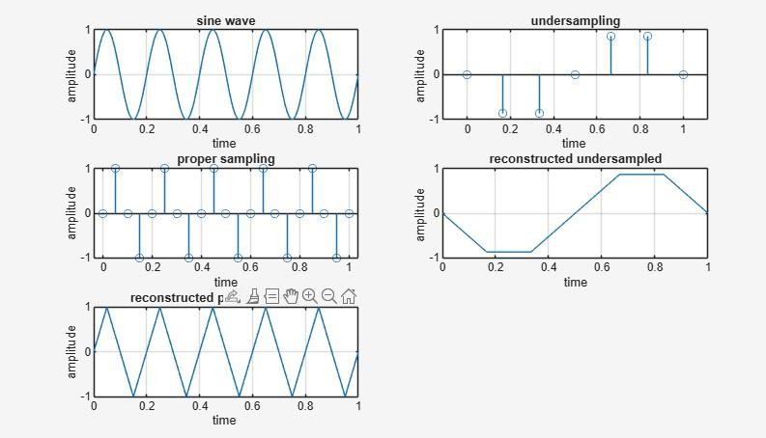

Enter amplitude=1
enter the frequency of message signal fm=5 enter the sampling frequency fu<2fm is fu=6 enter the sampling frequency fp>2fm is fp=60

